MODULE 4 – INTRODUCTION TO DBMS

LAB EXERCISES

14. SQL Joins
Lab 1.
Perform an INNER JOIN between books and authors tables to display the title of books and their respective author’s name.
Ans.
1. ALTER TABLE books ADD author_id int;
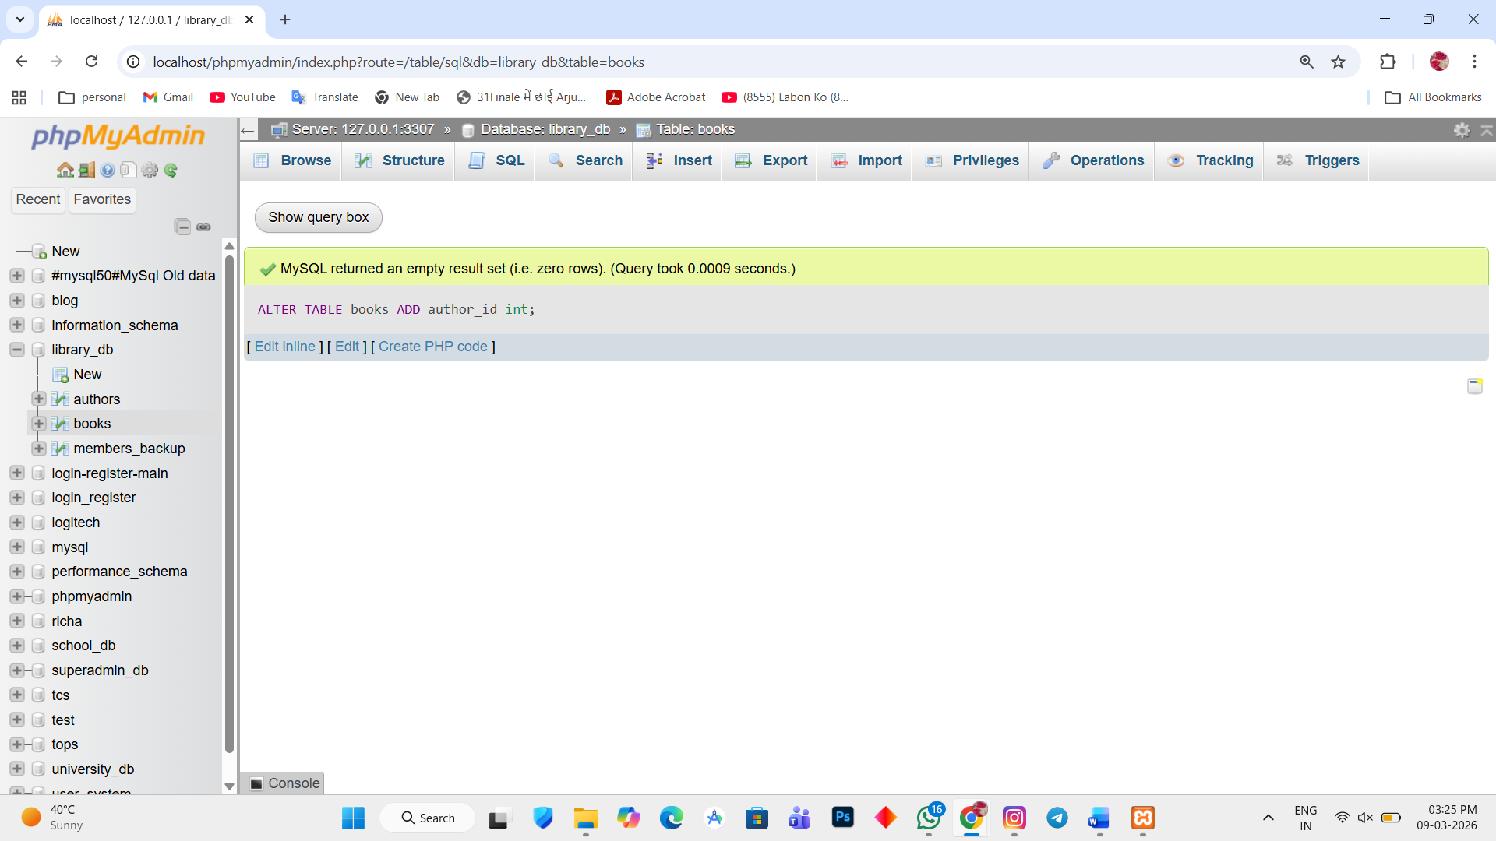

2. UPDATE books SET author_id = 1 WHERE book_id = 1;
UPDATE books SET author_id = 2 WHERE book_id = 2;
UPDATE books SET author_id = 3 WHERE book_id = 3;
UPDATE books SET author_id = 6 WHERE book_id = 6;
UPDATE books SET author_id = 7 WHERE book_id = 7;
UPDATE books SET author_id = 8 WHERE book_id = 8;
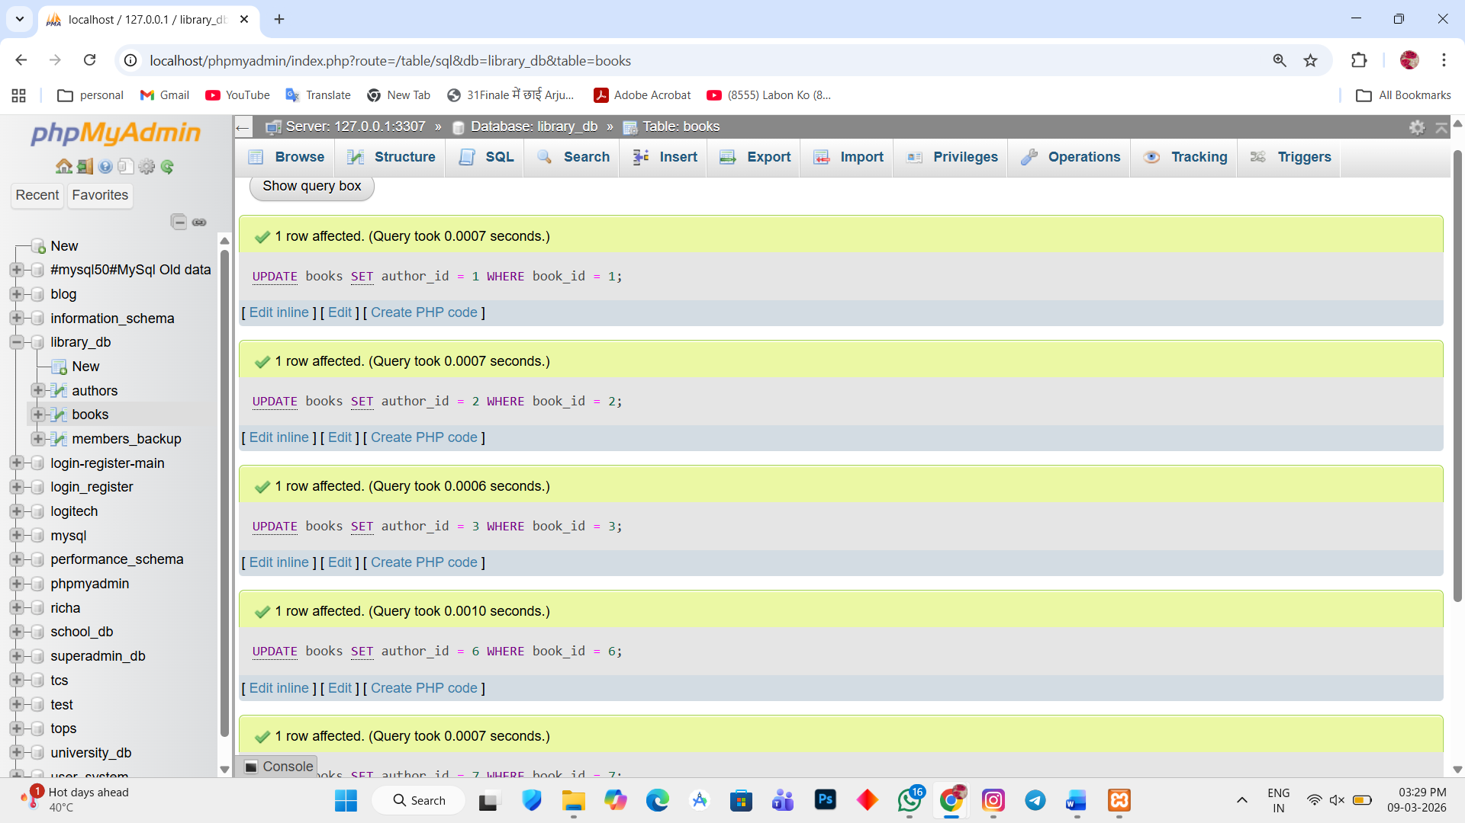

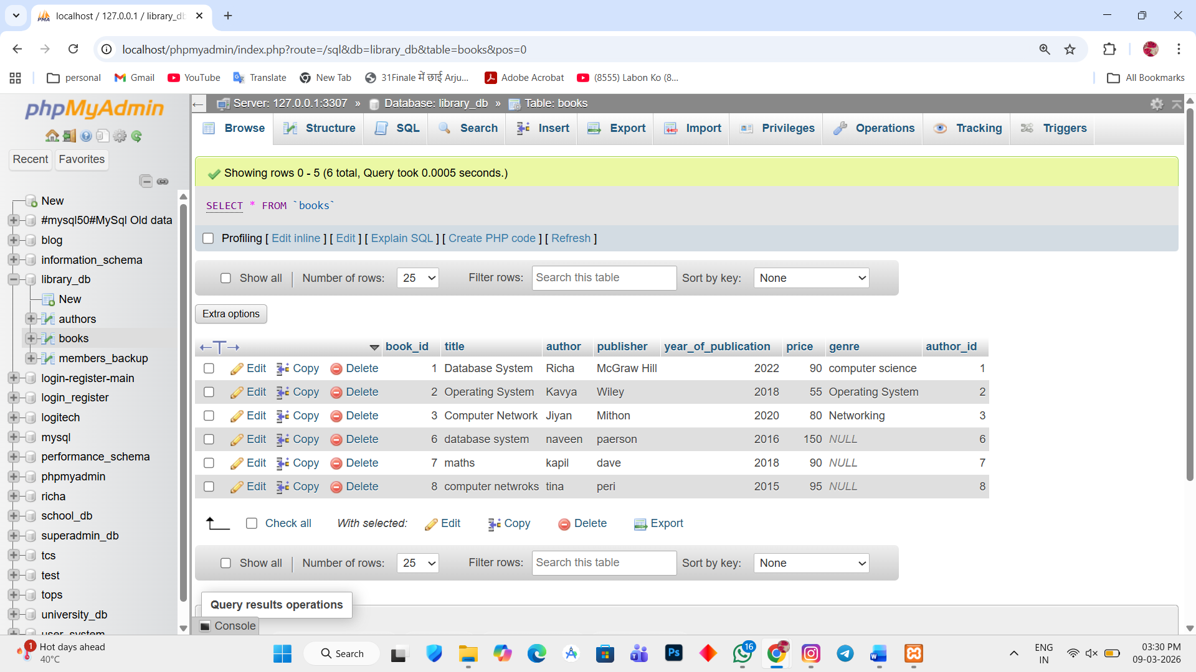

3. SELECT books.title, authors.first_name, authors.last_name FROM books INNER JOIN authors ON books.author_id = authors.author_id;
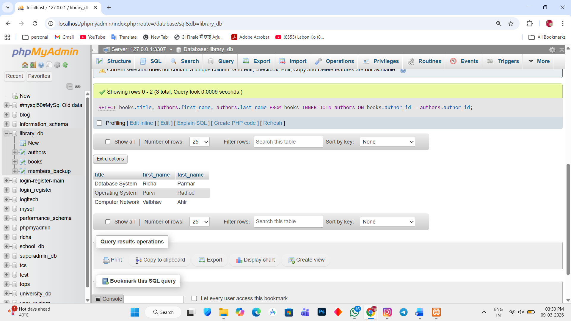

Lab 2.
Use a FULL OUTER JOIN to retrieve all records from the books and authors tables, including those with no matching entries in the other table.
Ans.
1. SELECT books.title, authors.first_name, authors.last_name FROM books LEFT JOIN authors ON books.author_id = authors.author_id
UNION
SELECT books.title, authors.first_name, authors.last_name FROM books RIGHT JOIN authors ON books.author_id = authors.author_id;
